
Customer Access and Performance
Area Committee Wellbeing Fund Large Projects (Inner North West)

West North West Area Support Team
1st Floor, The Old Library, Town Street, Horsforth, Leeds, LS18 5BL

 0113 336 7856
 west.north.west@leeds.gov.uk

INW Area Committee Wellbeing Fund Large Projects Guidance Notes

Please read these guidance notes BEFORE completing the application form

Our Priorities

The Area Wellbeing Fund Large Projects Programme has been set up to provide funding to support projects that address the priorities of the Area Committees and to help local community activities flourish. Before you submit your application make sure that your proposed project meets at least one of these themes and priorities:

THEME | PRIORITIES
Sustainable  Economy and  Culture | - Provide opportunities for people to access jobs or learn new skills.  - Make better use of our community buildings.  - Support the regeneration of local district centres.
Safer and Stronger Communities | - Fight crime and antisocial behaviour, with a particular focus on reducing burglary rates.  - Consult local people about changes that may affect their lives and support them  to get involved in local decision making.  - Develop strong network of community groups so they are able to contribute  to improving their neighbourhoods.  - Support volunteering within our local communities.  - Improve the local environment including parks and open spaces.
Health and Wellbeing | - Promote healthy lifestyles and tackle health inequalities.
Children and Families | - Provide opportunities for children and young people to access out of school activities.
Housing and Regeneration | - Improved public service co-ordination ensuring that services work together  with local residents to improve our most deprived neighbourhoods.  - Ensure that the public are informed of planning issues as they relate to the  Inner North West.

What can be funded?

You can apply for any amount to undertake projects that address the priorities of the Area Committees as described on the front page. Your project should provide something new or significantly enhance and add value to existing provision. These might include:

- Costs related to holding a community event such as venue hire, publicity, translation and signing costs, registered childcare costs and transport to and  from the event.  - Environmental improvements to improve the appearance of the neighbourhood and increase  access to greenspaces eg. landscaping,  new fencing/railings, installation of bollards.  - Crime prevention initiatives to improve community safety, prevent crime and reduce fear of crime e.g. alleygating, CCTV, lighting, signage. | - Resources required for groups to run a community initiative such as equipment/materials, publicity materials, training costs, educational trips, residential courses or consultant/speaker fees.  - Improvements to leisure facilities to improve opportunities for sport, play and healthy activities for all ages e.g. creation of new play area, provision of adventure playground, installation of changing facilities.  - Improvements to community facilities for use by local residents or organisations providing services locally e.g. installation of toilets/kitchen facilities, lighting, heating.
Please note, Area Wellbeing Fund cannot be used to :

- Fund the everyday running costs of a community organisation (including general building maintenance costs)
- Pay for costs relating to projects with religious or political aims
- Pay for any projects/part of projects that have already taken place
- Fund any project not benefiting the Wards covered by the Area Committee (see Q8 below)

To be eligible for funding your Group/Organisation must have the following:

- Appropriate management arrangements and finance controls in place
- Relevant policies to comply with legislation and best practice e.g. equal opportunities, child protection
- Demonstrate it has the experience and/or ability to undertake the project
- Be clear on how you will measure the success of the project
- If applying for capital funding you must have arrangements in place for ongoing repair/maintenance
- You must be unable to fund all of the costs for the project yourselves or from other grants

Revenue or Capital Funding?

Wellbeing Funding is split into two types, Capital and Revenue. Revenue can be used for most projects and will pay for such things as set up costs, equipment, repairs and things which may have an ongoing or recurring cost.

Capital funding is used when buying an asset such as a building, where you are making a major alteration / improvements to property (such as building an extension or landscaping). Capital can also be used for one off large scale investment in equipment, where it adds value to an asset and has a lifespan over two years.

How to apply & timescales

The Inner North West Area Committee allocates their wellbeing funding through a commissioning round, before the start of the new financial year in April. Please contact the Area Support Team for the deadline for the submission of large grant applications.

Once a grant is approved, funding will be paid in arrears of a the project e.g. quarterly or on completion of the project, unless previously agreed with the Area Support Team.

Please note that groups and organisations can only receive funding once within a financial year.

If you have any queries please contact the Area Support Team.

GUIDELINES FOR COMPLETING THE APPLICATION FORM

1. | Name of Project  Please give the name of the proposed project.
2 (a) | Name of Organisation / Group  This is the organisation that will be responsible for any funding given and who we will contract with delivering the project activity. The Organisation will be responsible for completing the application form, and for ensuring that the project is completed within the set timescale and within the agreed budget.
2 (b) | Organisation address  Please provide the full correspondence address, telephone and fax number of the Organisation/Group named in 2(a).
2 (c) | E-mail address  Please provide the email address for the Contact Person named in 2(d) (if they have one).
2 (d) | Contact Person and position  Please give the name and position of the person who will be taking on managerial responsibility for the project, and with whom the Area Support Team will have contact.
2 (e) | Organisation Type  Please tick the box to show the status of the organisation applying for the funding eg. charity, voluntary group, community group, company limited by guarantee, Council etc.
2 (f) | Company/Charity Registration Number  If applicable please enter the company or charity registration number.
3 | Project description  Please provide a full description of what the funding you are applying for will go towards achieving. Please include the aim and details of the project, how many people will benefit and what the funding will be used for.
4 (a) | Total cost of your project  This is the total costs of the project which includes all contributory funding.
4 (b) | Funding from other sources  Please identify any other funding that may contribute to this project e.g. Lottery funding £1,000.
4 (c) | Amount of Area Wellbeing funding requested  This is the amount of funding from the Area Committee required for the duration of the project.
4 (d) | When will the project start? / When will the project end?  Please state the dates when you plan to start and complete the project.
5 (a) | Please list the main outputs of your project  Please state what the actual results of your project will be, eg. installation of seating, refurbishments of a village hall, provision of youth activity in an area, gala event taking place.
5 (b) | Please list the main achievements of your project  Please state how your project will make a difference to the people in the this area and the achievements it will make.
6 | What previous experience (if any) have you of delivering similar projects?  Please give details of any projects you have delivered which demonstrate that you have the ability to meet the outcomes and achievements highlighted in this form.
7 | Are there any other organisations involved in the project?  Please detail any other organisations that are helping to deliver your project, groups which your project will signpost and link into, or organisations which have helped to fund your project.
8 | What items do you want the funding to pay for?  Please list all items which the Area Wellbeing Fund contribution will pay for in full or in part. If you are unsure as to whether your project is revenue or capital please contact the Area Support Team. Please note that you should obtain three quotes or go through a tender process for any equipment or service that is to be purchased. If further information is required, the Contract Procedure Rules can be found on Leeds City Council’s Website – www.leeds.gov.uk
9 | How will you ensure that your project will be value for money?  Please tell us how you have checked that your project will offer good value for Leeds City Council funding. This could include, seeking a number of tenders or quotes, or comparing it with similar projects.
10 | Have you applied for any other funding for this project?  If your organisation has applied for funding from other sources for this project, please give details of who you have applied to, how much you’ve applied for and when you expect to find out the outcome of the bid.
11 | Please explain how you will meet any shortfall in funding for the project  Please detail how, if you were unsuccessful in securing the full amount of funding outlined in your application, would you secure other funding or modify your project so that it would still deliver its outcomes.
12 (a) | Bank account details  Please include the name of the organisation’s bank account and the names of the signatories to the bank account. If there are more than two signatories please let us know who the other signatories are.
12 (b) | Name of Finance Manager  Only applicable to Leeds City Council applicants.
13 | Which of the Area Committee’s themes/priorities does your project meet?  Please tick the theme(s) your project meets. In the box write how your project meets the priorities identified. A full list of themes and priorities can be found on the front of this form. If you are unsure as to which priority your project would fall into please contact the Area Support Team.
14 | Which areas will benefit from this project?  Please give details of the Neighbourhood(s) and/or Ward(s) that will benefit from your project. Please refer to the enclosed map for ward boundaries. Projects can only be funded if they benefit the residents of the relevant wards:  - Weetwood  - Headingley  - Kirkstall  - Hyde Park & Woodhouse
15 | What consultation has been done to identify the need for this project?  Please provide details of any consultation that has been done and why you think project is needed. If consultation has not taken place, outline how you have determined a need for this project.
16 | How do you know that your project does not duplicate an existing facility, service or activity currently existing in the community and surrounding area?  Please provide information on any services or activities you are aware of in the area that deliver similar outcomes to those of this project.
17 (a) | Who owns the building/land where the works/project will take place?  Please provide information on the owner of the building/land where your project is taking place.
17 (b) | If you do not own the building/land tell us what permission you have from the owner to undertake the works/project there and what arrangements are in place to ensure ongoing access/benefit for your organisation/local residents  Where your activity is taking place in a building or on land not owned by your organisation, please provide evidence of the permission you have with the owner of the building/land, eg. letter from owner granting permission, lease, minutes from meeting.
18 | What are the potential risks attached to your project and what preventative action have you taken or will you take to avoid them?  Please fill in the table identifying any potential risks for your project and the action would/will take to avoid or minimize them.
19 (a) | What is the proposed timetable for your project?  Please give your proposed start/finish date and any key dates/activities that will take place throughout its duration.
19 (b) | How would you ensure that this project will be completed to the standard and timetable specified?  Please detail the ways in which you will monitor your project to make sure that it is running to the timescale and delivering what you have said it will.
20 | Please provide details on how you intend to promote this project and how your organisation encourages people to take part and/or help with activities you provide?  Please give details on any publicity, word of mouth, current contacts your organisation already has that will be used to promote the project.
21 | How will you evaluate the success of your project?  Please detail the things that you will measure, which will indicate that your project has been a success.
22 | How many people are involved in the delivery of this project?  Please provide the number of Management Committee Members, Staff and Volunteers involved.
23 (a) | Please provide details regarding which sections of the community your project will engage/work with You will need to indicate the different sections of the community that your project will engage or work with. The type of equality groups to consider are age, disabilities, gender, race, religion & belief and sexual orientation. Please tick the relevant equality group(s) and tell us in the second box how you will achieve this.
23 (b) | Please detail how you have considered community cohesion or any other equality issues in the planning of your project  You need to tell us what equality and diversity issues you have considered in the planning of your project and how this has shaped the project you will deliver. You need to say what the impact of your project will be on different groups (eg. will it favour some and disadvantage others). Please describe how your project will promote good community relations between different groups eg. young and old, and how barriers that might prevent their involvement will be overcome. For example you may have chosen a venue because it is in a more central location to different groups, has childcare facilities or better disabled access.
24 | Has your organisation received funding from Leeds City Council in the past?  If your organisation has previously been awarded Leeds City Council funding, please provide details of the type of funding, purpose and which fund/Directorate/Service it came from.
25 | VOLUNTARY AND COMMUNITY ORGANISATIONS ONLY - Documents  If your organisation is a voluntary or community group, please attach the listed documents. If you do not have the listed documents, please let us know why.
26 (a) | CAPITAL WORKS ONLY – Does the building/land have any special statutory designation? If yes, please give details of the designation, date of issue (if known) and how your proposal will affect it  Please provide details as requested.
26 (b) | CAPITAL WORKS ONLY – Does your project require planning permission or other form of consent? Please give details and attach copy of decision notice/consent  If the project does require planning permission please attach a copy of the decision notice/consent.
26 (c) | CAPITAL WORKS ONLY - Who will be responsible for ongoing maintenance/repair and what insurance arrangements will there be?  Please provide information and/or evidence of who will be responsible for the maintenance and repair works and the insurance arrangements.
27 | Declaration  Please check that the application form is complete and that you have read the guidance notes before submitting the form. If you have any queries, please contact the Area Support Team for assistance. Once you have completed the application form, please return it together with your supporting documents listed at Question 25 to the Area Support Team (details are on the application form). If you are intending to email your application, please ensure the email comes from the named applicant at Question 2(d) and not a different member of the organisation.

What happens after you submit your application?

We will discuss any queries we may have about your application with you and following that your application will sent to the Area Committee Members who will decide whether to accept or reject your application. A decision will be made at the Area Committee (7th March 2013) and we will inform you of this after the meeting.

If your application is approved we will send you a Funding Agreement and Project Delivery Statement for you to sign. We are unable to release the funding until we have received the signed copies back. These forms set out various conditions for this grant including the need to submit monitoring reports and receipts to us and the timescales for doing this. The receipts must match what your project is approved for. Please note - If you do not submit the appropriate receipts and progress reports within the stated timescales, we will take steps to reclaim the funding. In addition you will not be eligible to apply for further funding from the Area Committee.

Publicity

In all publicity, press, media and presentation materials and reports relating to the project, your organisation must acknowledge the source of the funding received for this project. This should be done by using the Leeds City Council logo alongside a statement as follows: ‘funded by the Inner North West Area Committee'. A copy of the logo can be sent to you if requested.

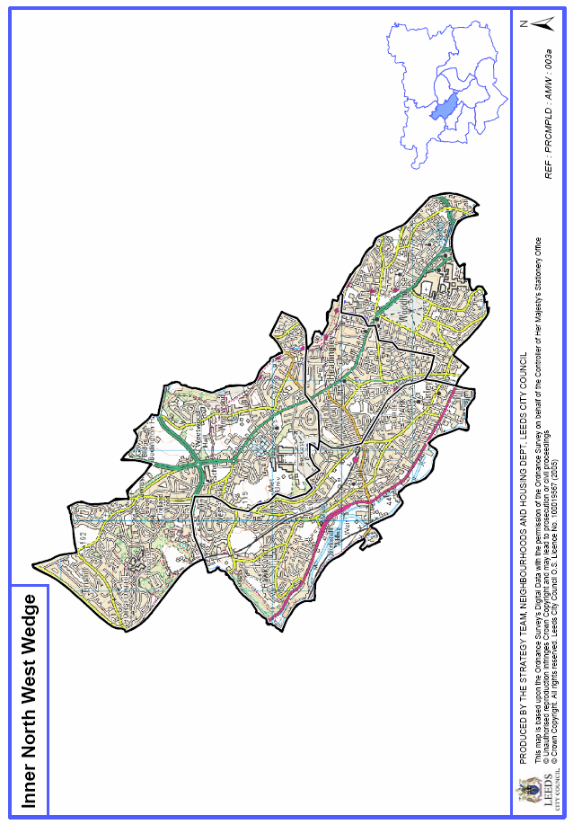

FINAL CHECKLIST

All sections of application form completed

Included any documents needed for Question 17 (b)

Included any documents needed for Question 25

Included any documents needed for Question 26

Filled in the declaration at Question 27

We accept applications and supporting documents submitted via email to west.north.west@leeds.gov.uk or in paper form; if you are intending to post your application, please ensure you have attached the correct postage to the envelope otherwise your application may not be delivered.

